**UNIVERSITY OF GHANA**

**SCHOOL OF ENGINEERING SCIENCES**

**DEPARTMENT OF COMPUTER ENGINEERING**

**CPEN 312: OBJECT ORIENTED PROGRAMMING WITH JAVA**

**UNIVERSITY ADMISSION MANAGEMENT SYSTEM (PROJECT NO: 4)**

**(PROJECT DOCUMENTATION)**

**GROUP MEMBERS**

* LESLIE ANNAN 10671152
* PETRA SARPONG 10665613
* SENAM ADAGBE 10669608

**SOFTWARES NEEDED** (All included in the “Software” Folder)

1. MySQL Workbench

2. JavaFx SDK (If JDK version is above 11)

3. JFoenix library.

**ADDING LIBRARIES TO INTELLIJ PROJECT**

1. Open File-> Project Settings

2. Locate the folder Software and search for ‘JavafxSdk’ Folder (In the read me folder).

3. Navigate to Modules->Dependencies-> + (on the right side) ->Select Library Type->Java

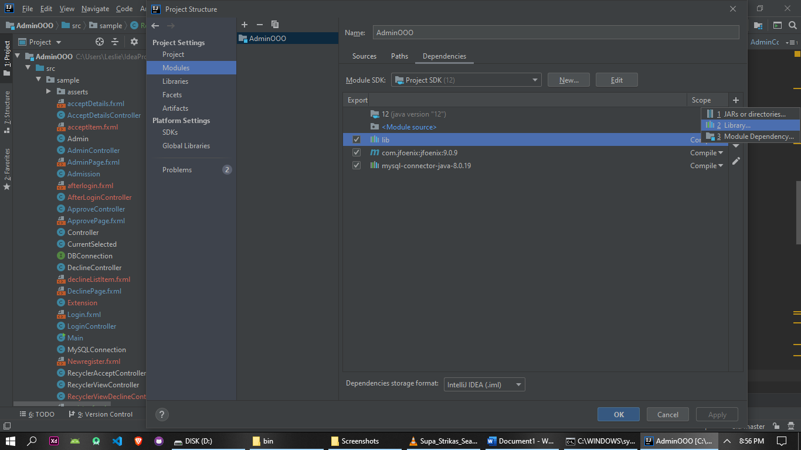

In the library dialog navigate to the Software folder and click on the JavafxSdk Folder.

Repeat 3. Navigate to the Software Folder and add the mysqlConnector.jar to the project.

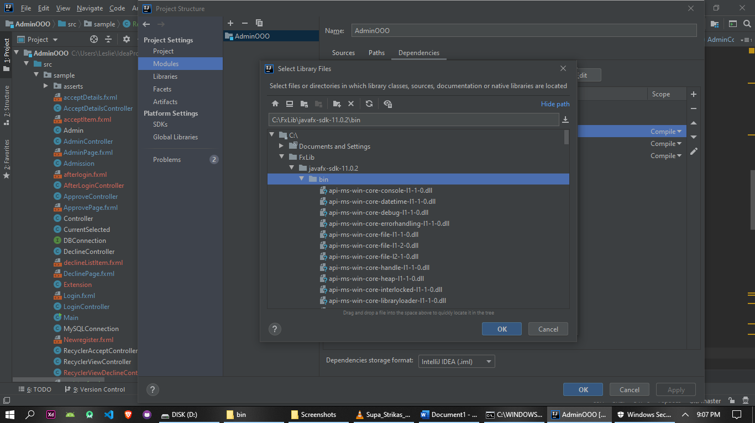

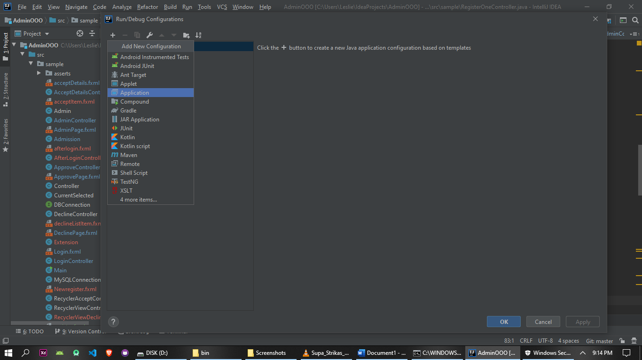4. Navigate to the Main-> + ->Applications

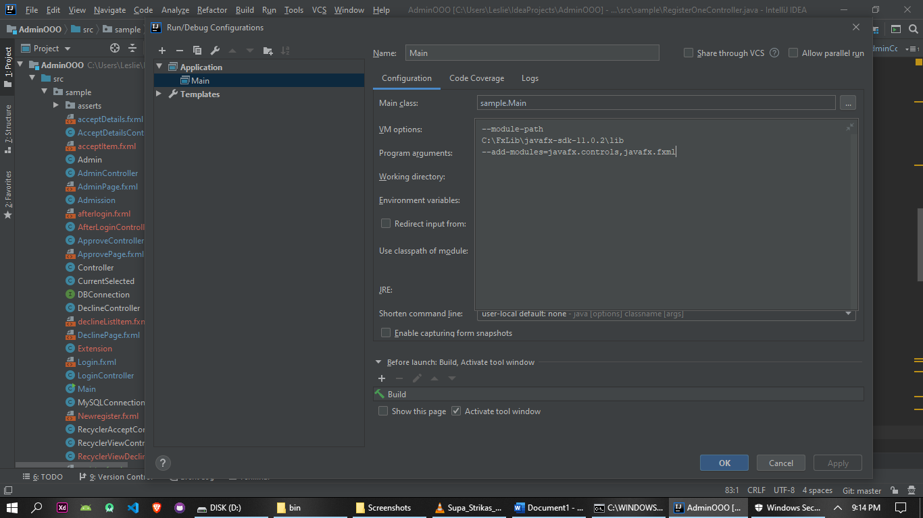

In the VM options add=> “--module-path pathToJavaFxSdk\lib --add-modules=javafx.controls, javafx.fxml ” excluding the double quotes

Example=>--module-path C:\FxLib\javafx-sdk-11.0.2\lib --add-modules=javafx.controls, javafx.fxml .

5. Click on ->Ok and Apply.

**ADDING THE DATABASE COLUMN TO LOCAL DATABASE**

1. Navigate to the Server and Click on Data Import.
2. Import the dumps files in the Softwares folder.

**This should import the admin database schema.**

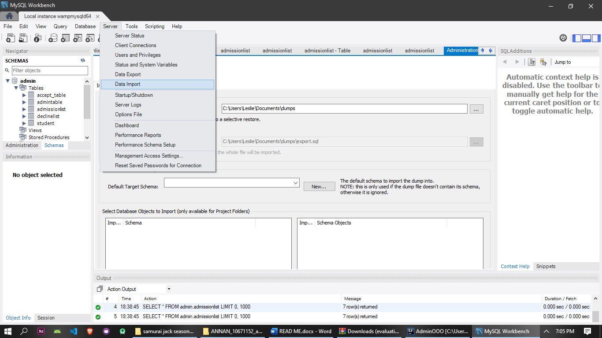

**SETTING PATH FOR PDF**

In the Extension class->method DocFile change the directory of the filename String to your local directory.

